

**NCC EDUCATION**

**LEVEL 4 DIPLOMA IN COMPUTING**

**Designing and Developing Object-Oriented Computer Programs**

|  |
| --- |
| Centre Name : NVL INSTITUTE  Assignment Title :  Exam Cycle : March 2018  Candidate Name : KHANTLINHTIKE  NCC Education ID No : 00178341  Submission Date : |
| Marker’s Comments :  Moderator’s Comments :  Mark: Moderated Mark: Final Mark: |



**Statement and Confirmation of Own Work**

***Each time you submit an assignment you must attach this statement as the cover page for both the hard copy and the electronic version. If the statement is missing, your work will not be marked.***

**Student Declaration**

I have read and understood NCC Education’s Policy on Academic Dishonesty and Plagiarism.

I can confirm the following details:

**Programme/Qualification Name**  : LEVEL 4 DIPLOMA IN COMPUTING

**Student ID/Registration Number**  :

**Name**  :

**Centre Name** : NVL INSTITUTE

**Module Name** : Designing and Developing Object-Oriented Computer Programs

**Module Leader** : Dr.Myat Mon Aye

**Number of words** :

I confirm that this is my own work and that I have not plagiarized any part of it. I have also noted the assessment criteria and pass mark for assignments.

**Due Date** : 6. May.2019

**Student Signature**  : Khant

Submitted Date  : 6. May.2019

Contents

Introduction 4

Acknowledge 5

Task-1 HTML 7

Task-2 CSS 9

Task-3Test the Website and Write a Test Report 11

Task-4 Critical Evaluation 13

Conclusion 14

References 15

# Introduction

My name is Khant Lin Htike. I’m 17 years old. I’m now studying at NVL institute. There are four subjects we have to learn in second semester. They are Designing and Developing a Website, Databases, Office Solutions Development, Designing and Developing Object-Oriented Computer Programs.

# Acknowledge

First, I want to appreciate to NCC Education for learning the Computing, which are popular nowadays. And I would like to thank for getting know from my university, NVL Institute. I want to thanks my Parents for fulfilling all my requirements to attend this school and support everything I need. I would like to thank to my lecturers, for giving me knowledge, make me feel happy, more interesting with this subject and thanks to class coordinators for encourage me, push me understand and being ready all the times when I need.

Task-1

# Task-1

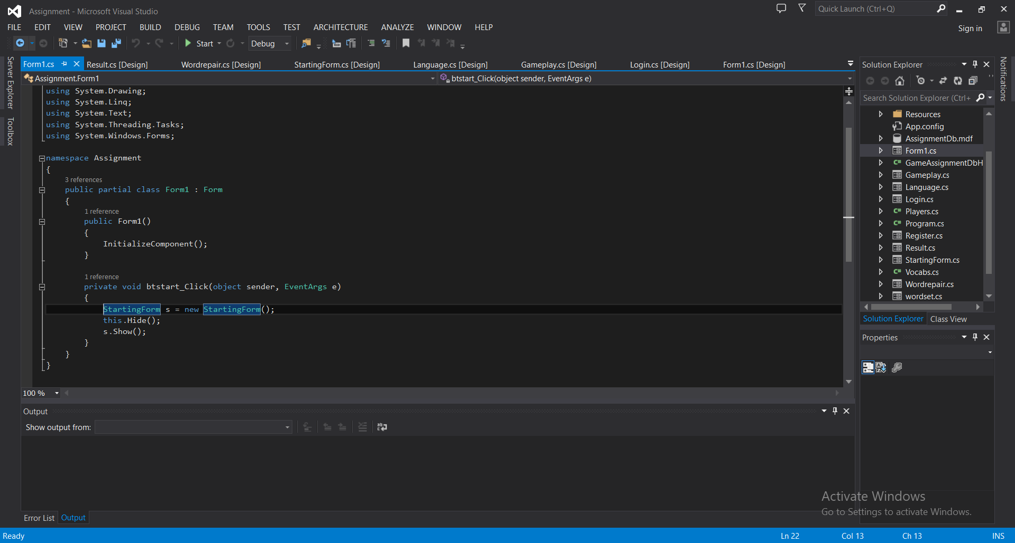

Fig 1-1

Register

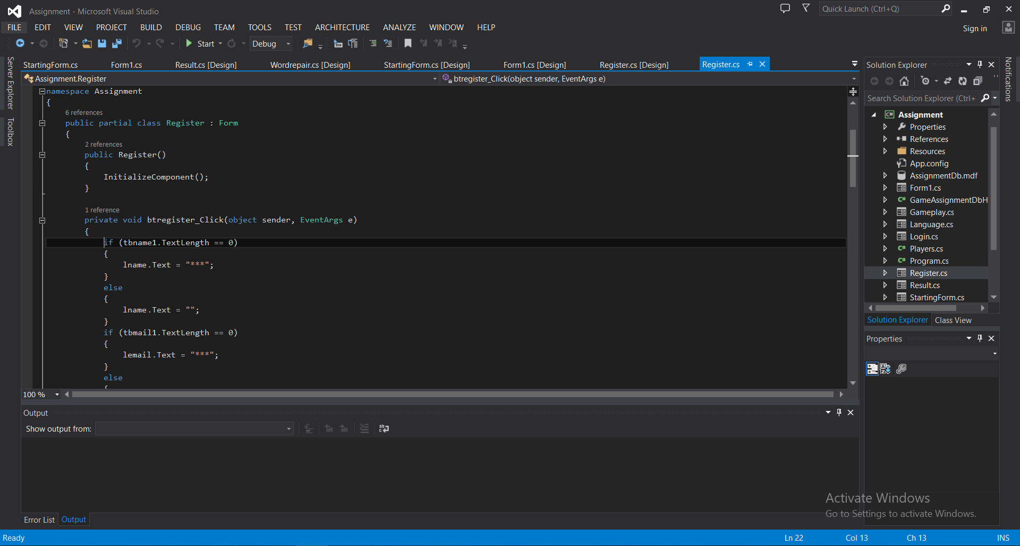

Fig 1-2

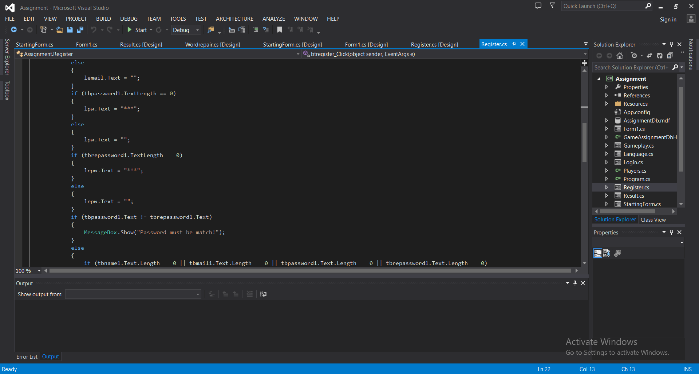

Fig 1-3

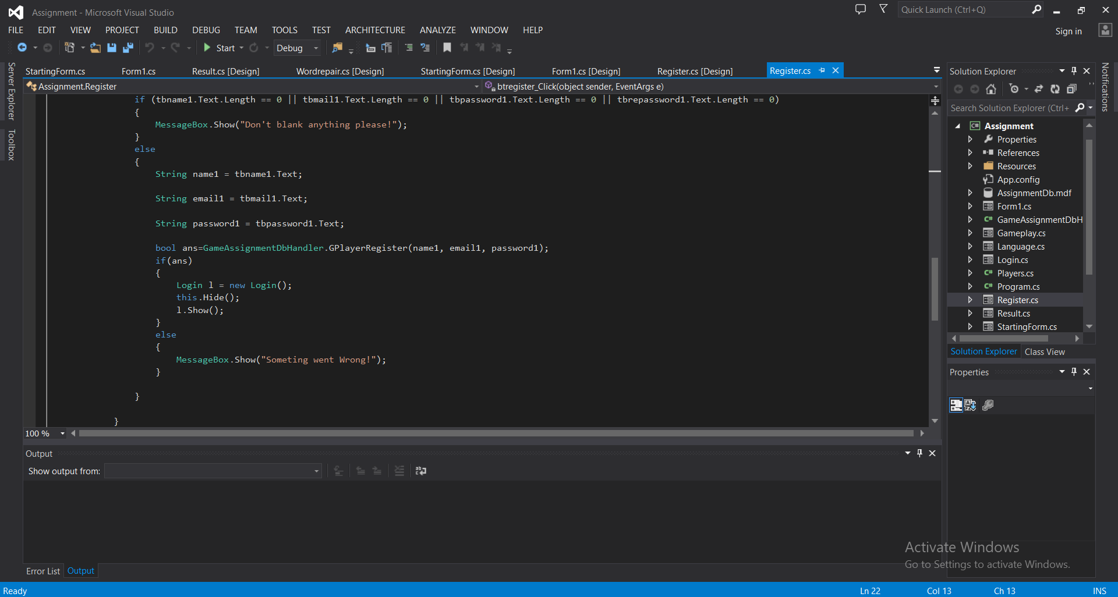

Fig 1-4

Login

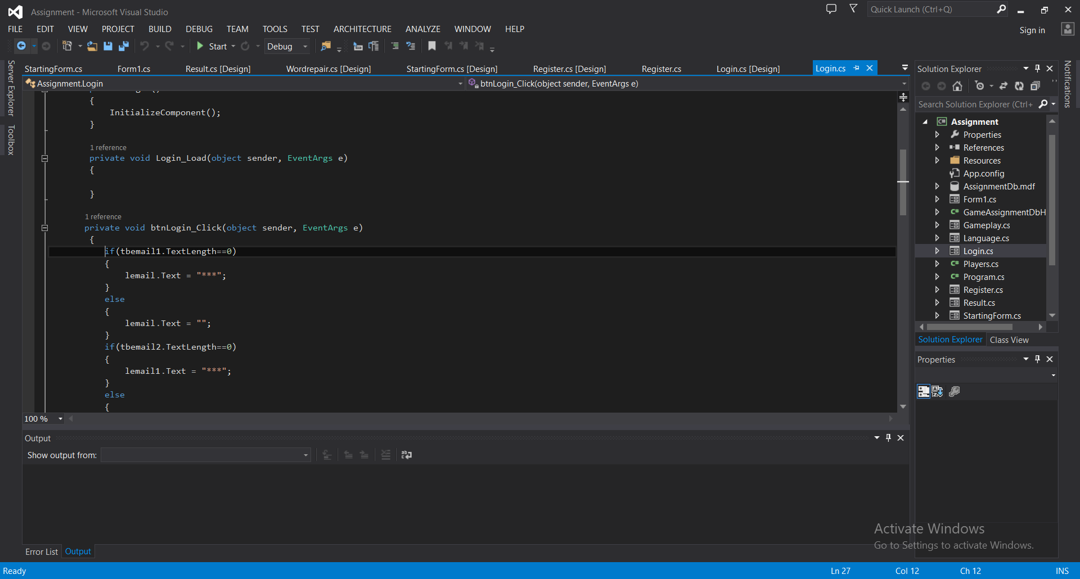

Fig 1-5

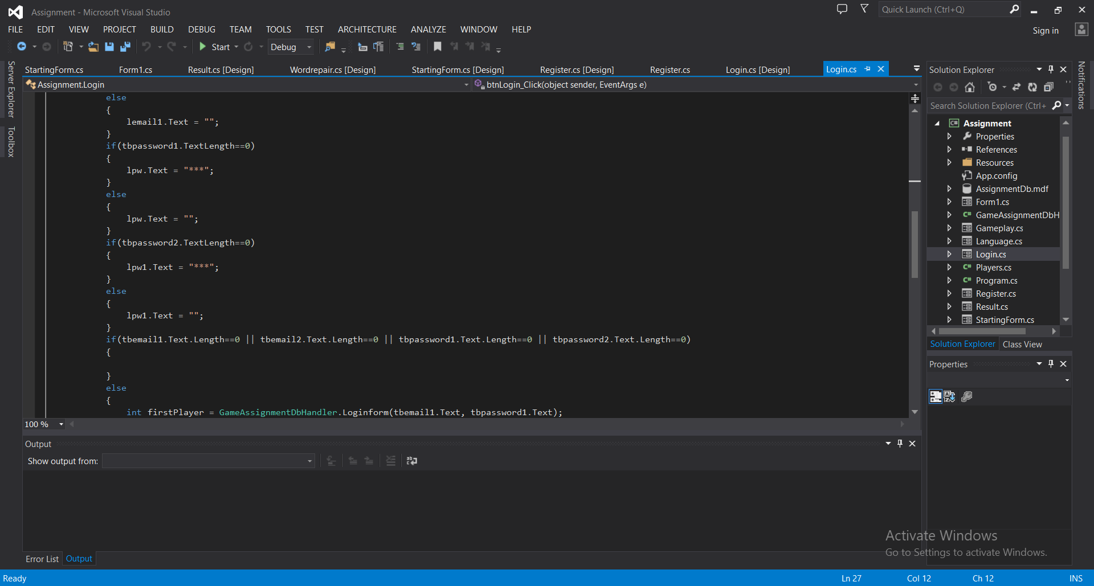

Fig 1-6

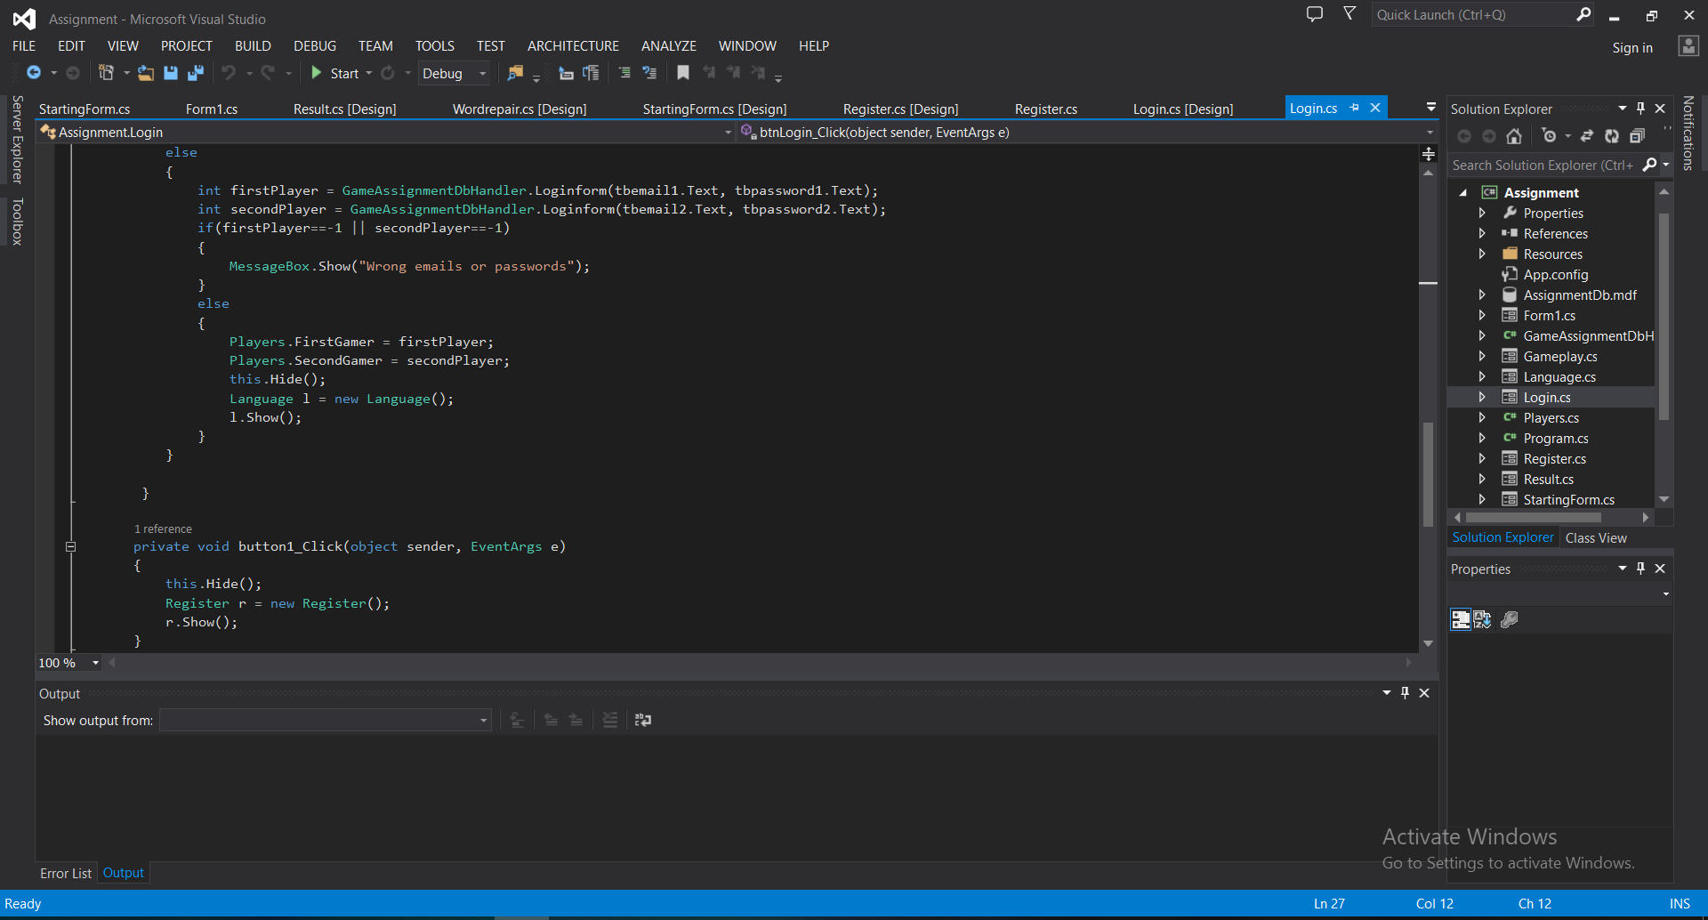

Fig 1-7

StartingForm

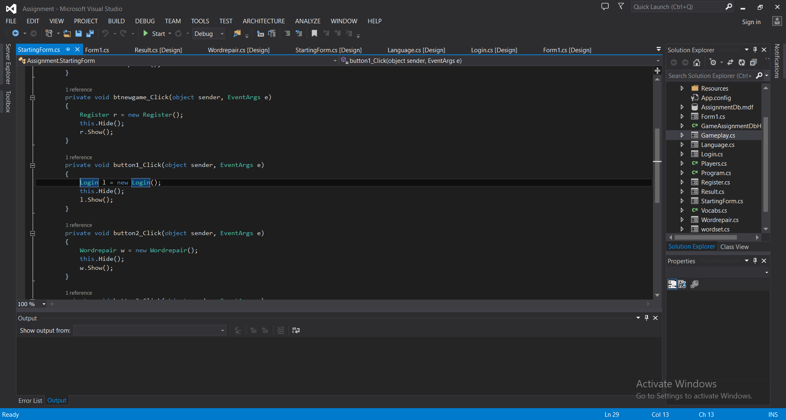

Fig 1-8

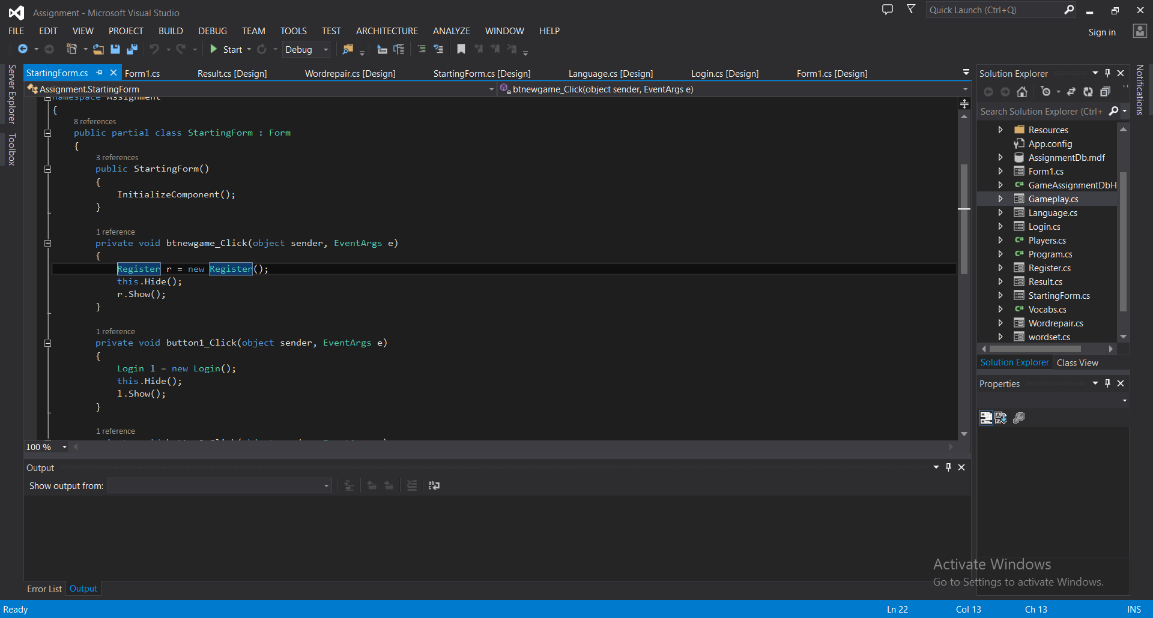

Fig 1-9

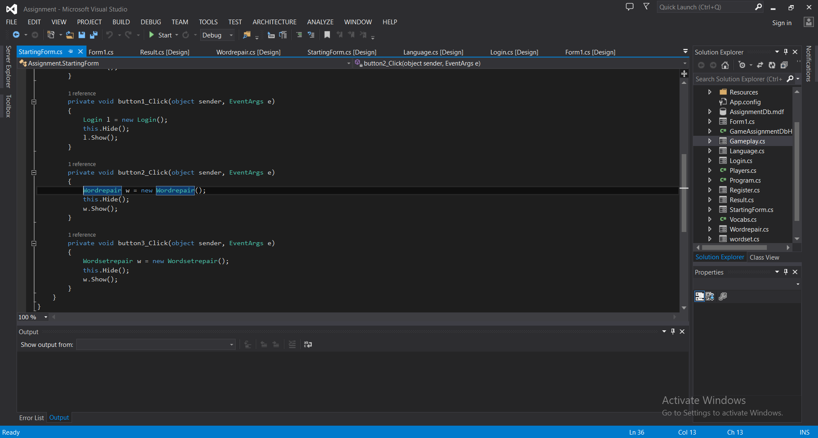

Fig 1-10

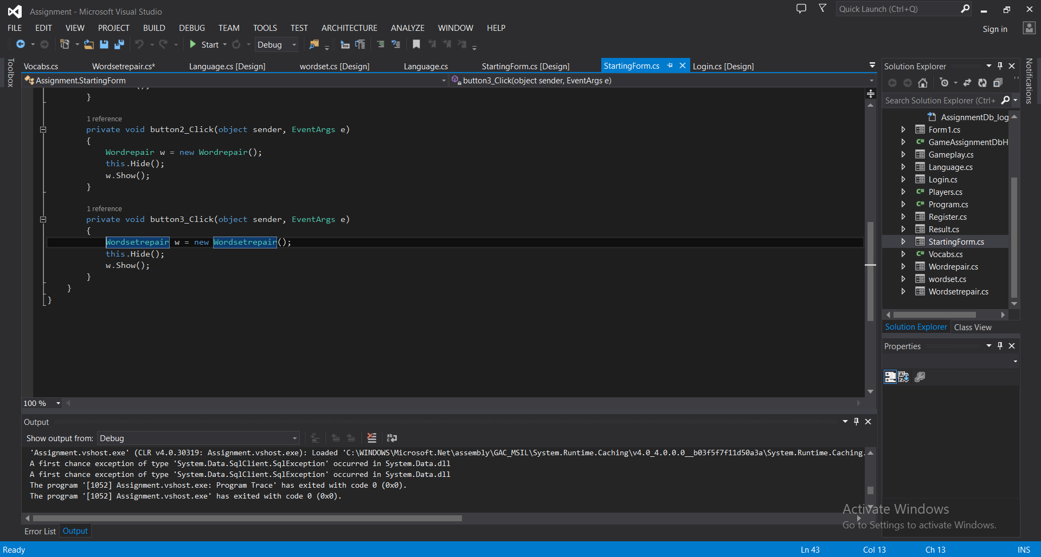

Fig 1-11

Language

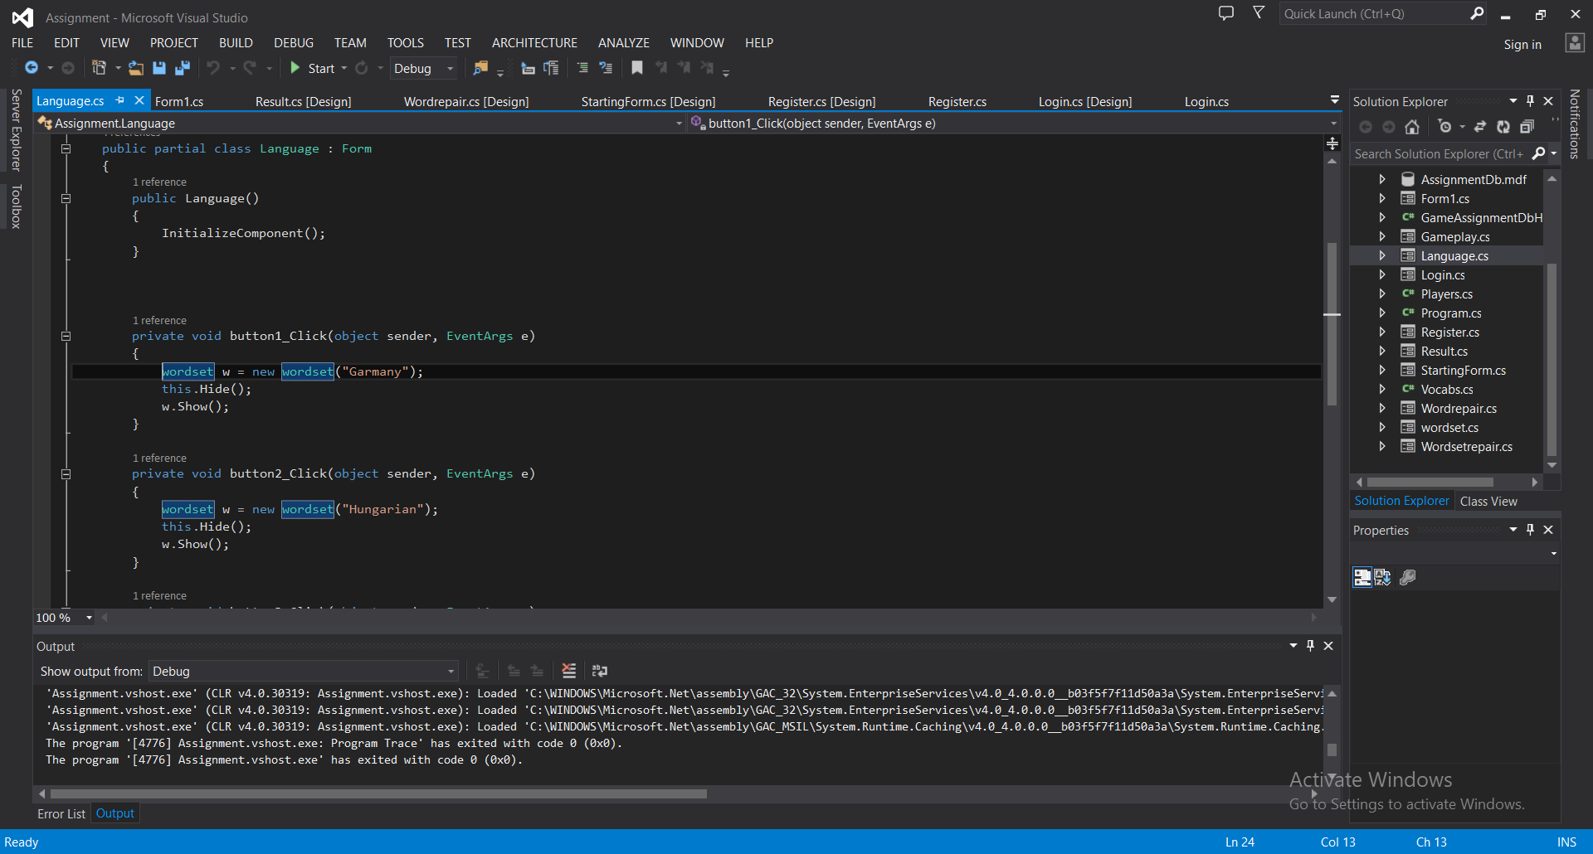

Fig 1-12

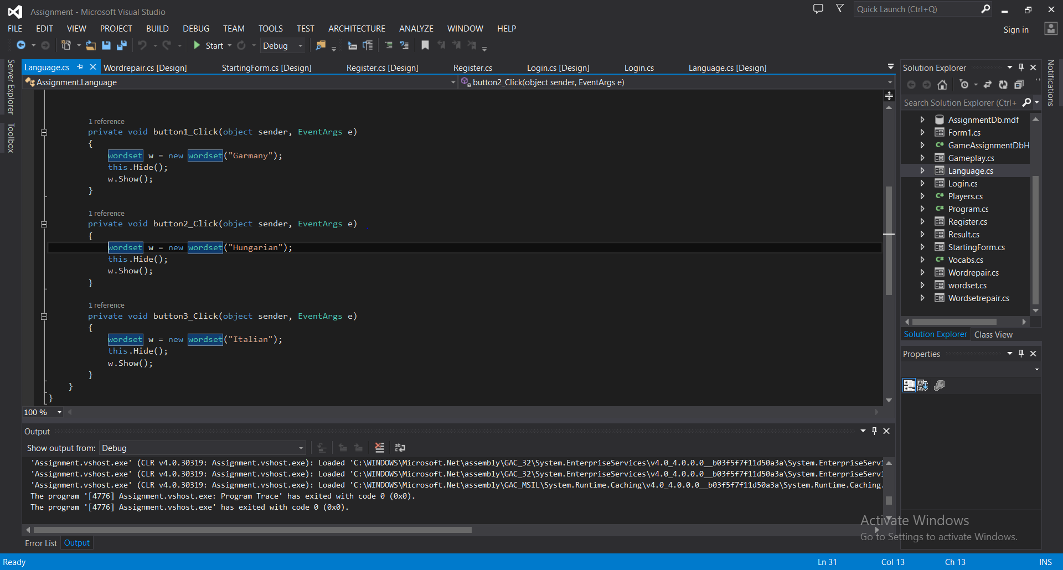

Fig 1-13

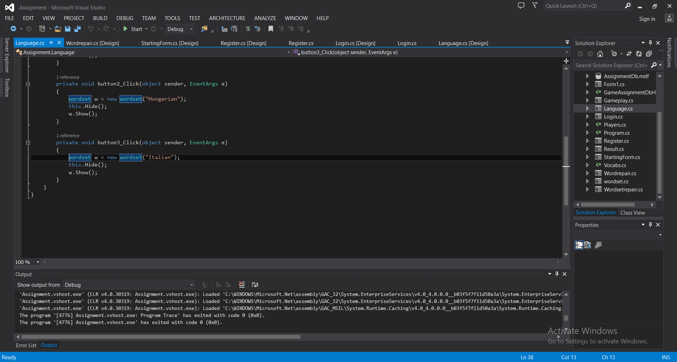

Fig 1-14

Wordset

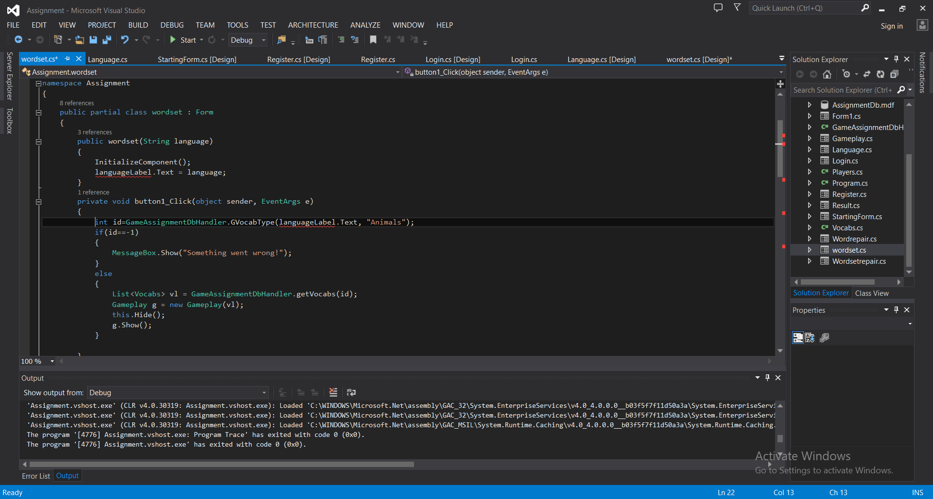

Fig 1-15

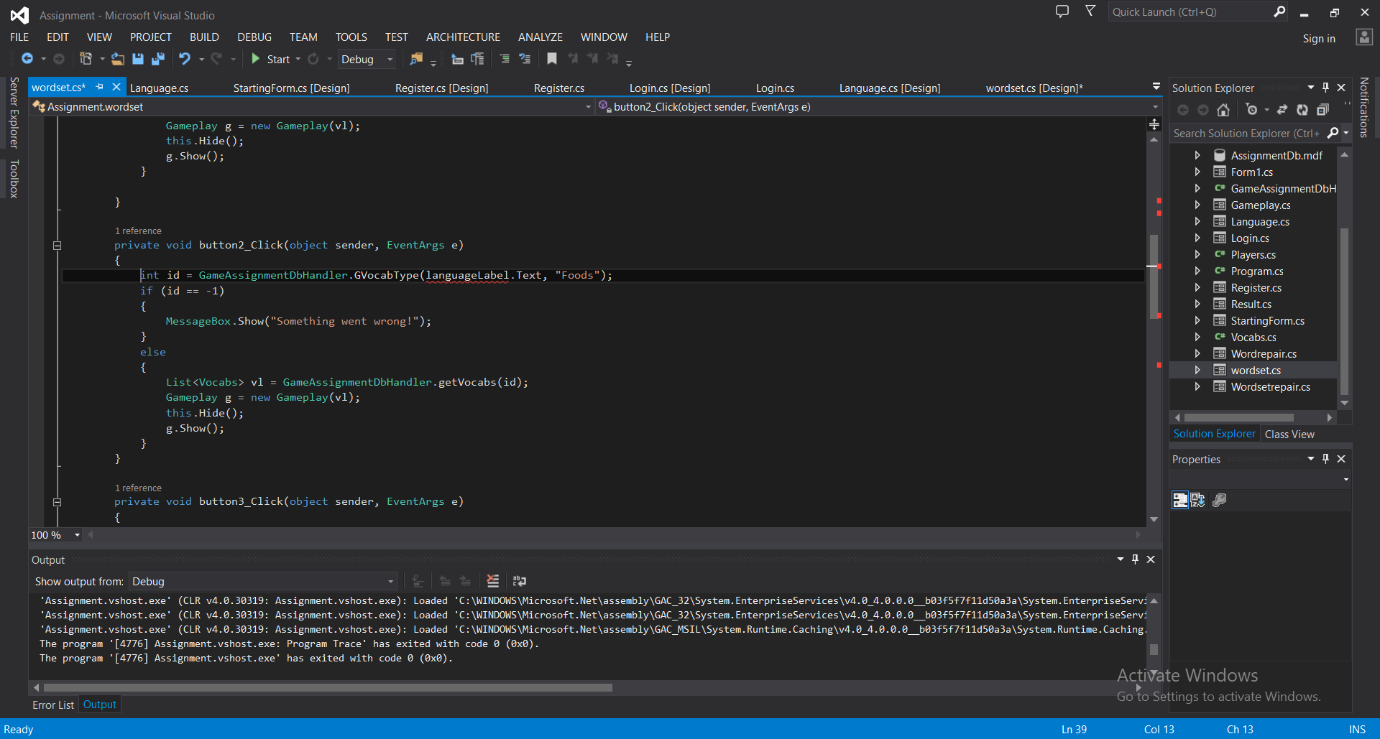

Fig 1-16

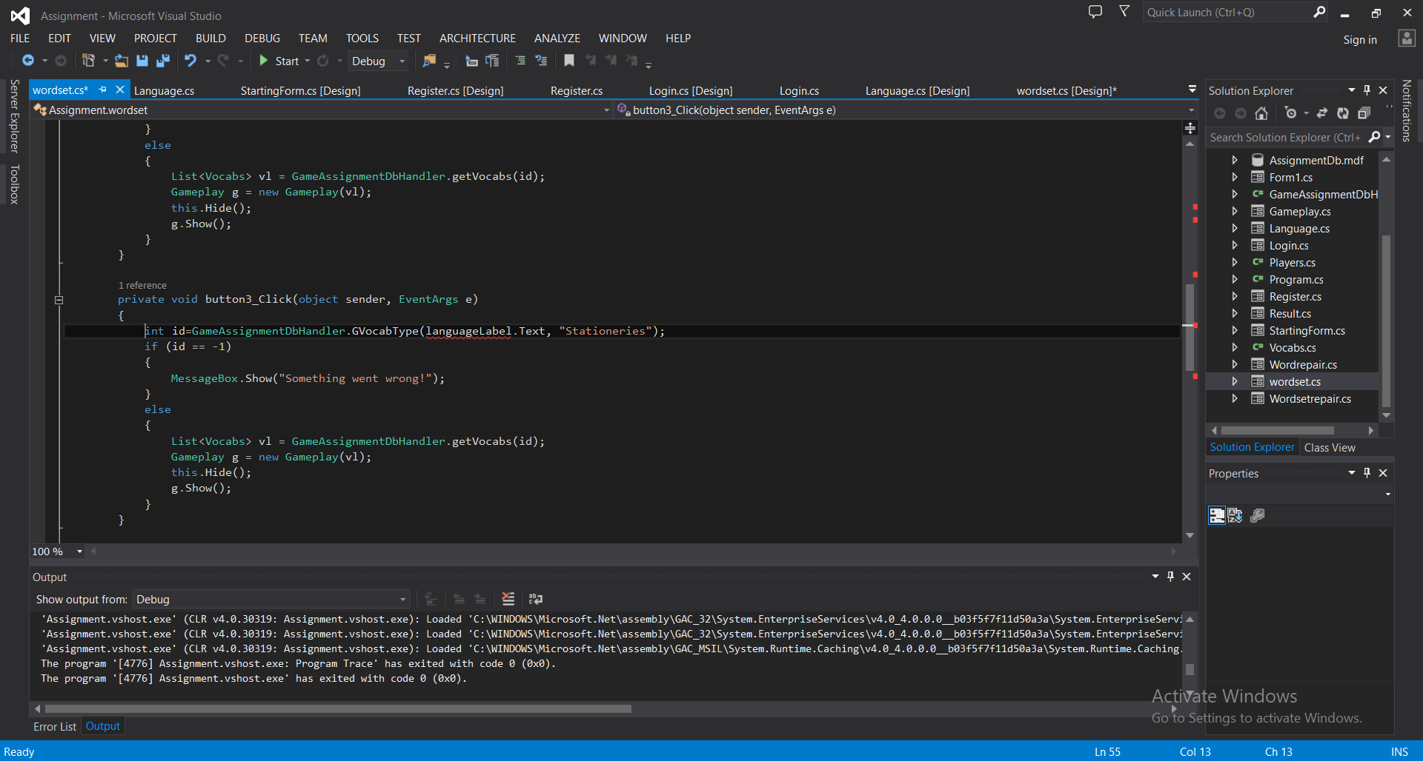

Fig 1-17

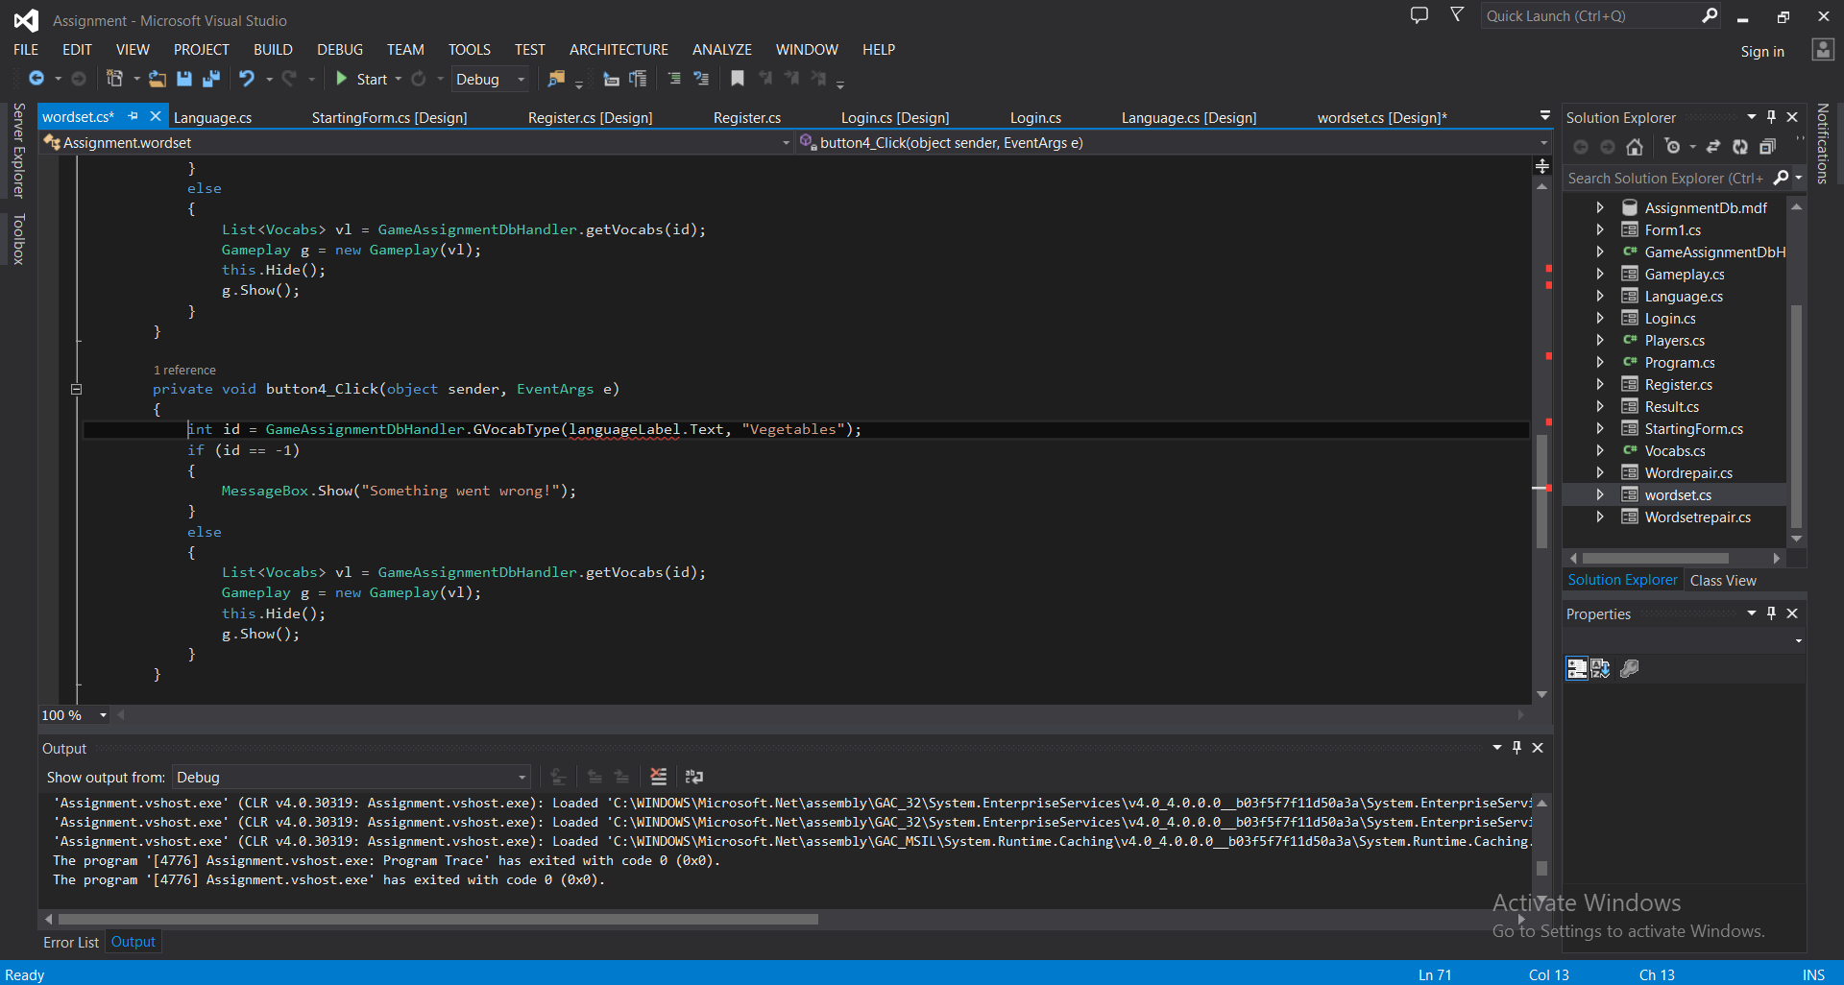

Fig 1-18

Wordrepair

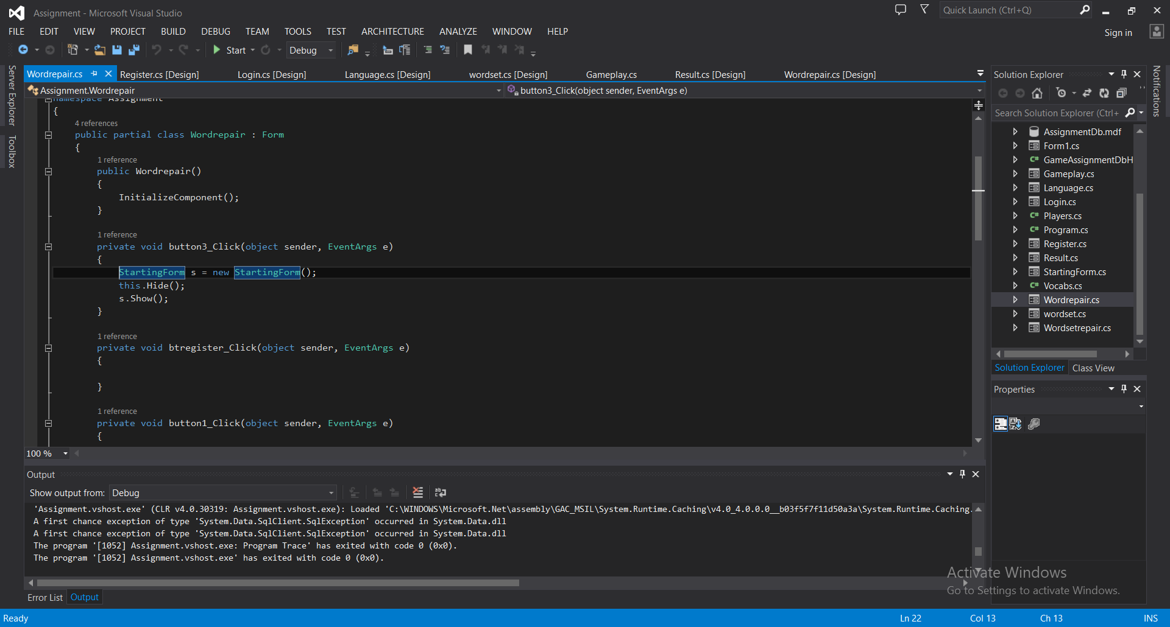

Fig 1-19

Wordsetrepair

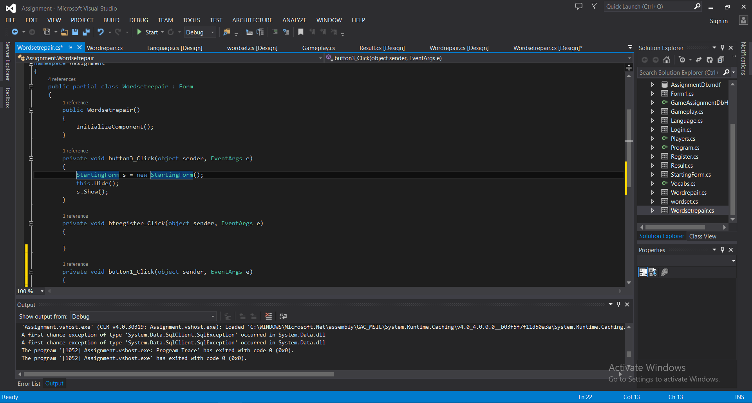

Fig 1-20

GameAssignmentDbHandler

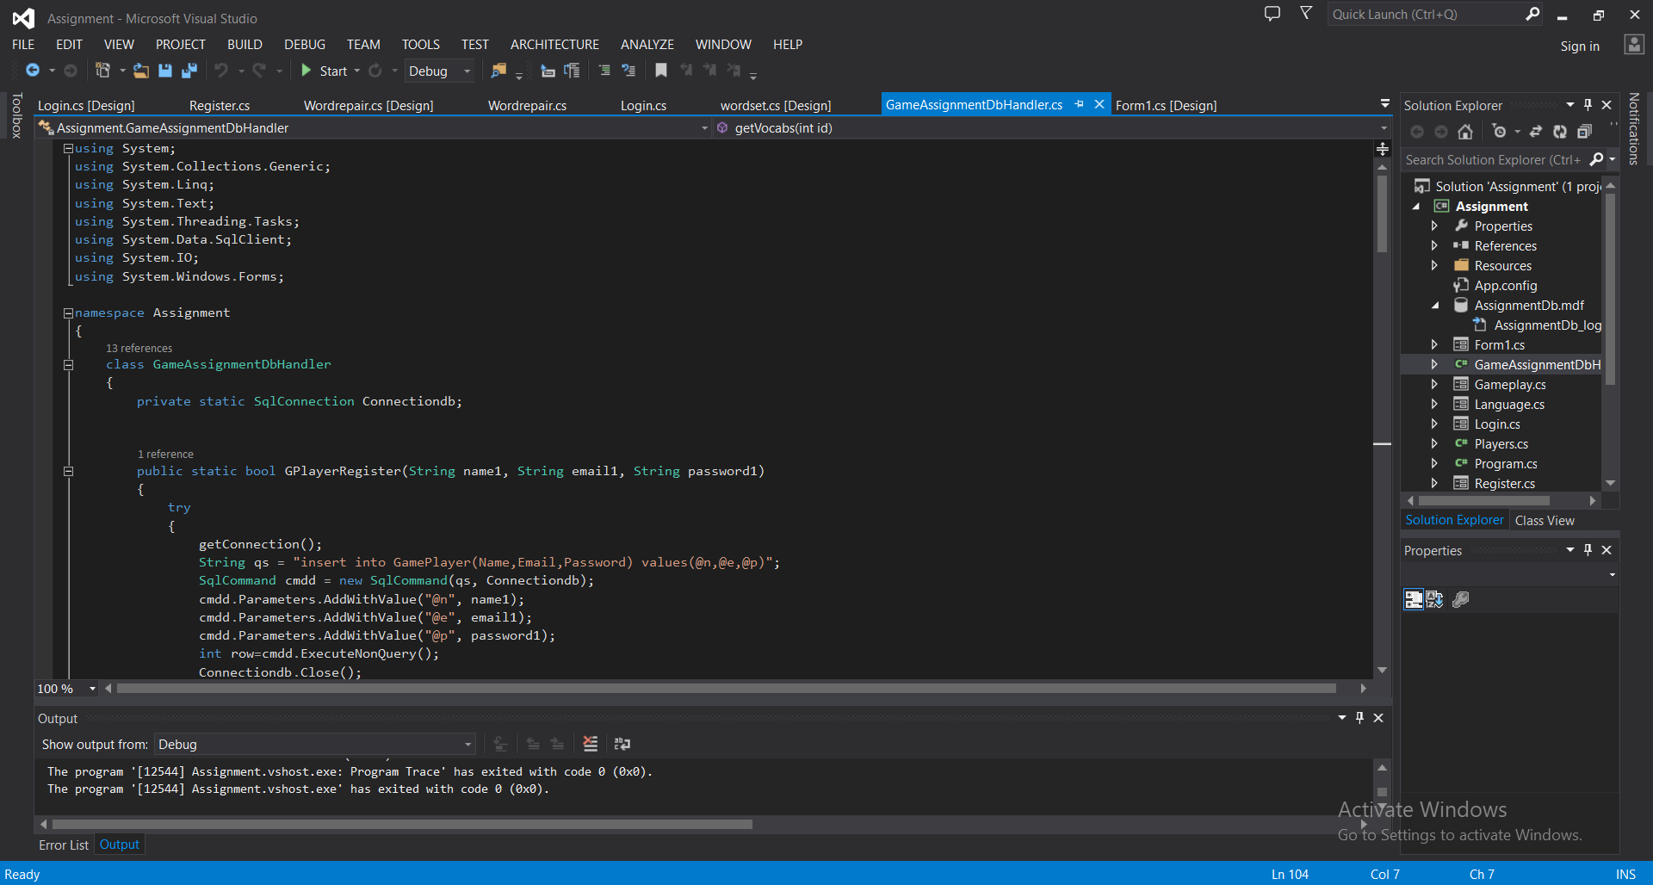

Fig 1-21

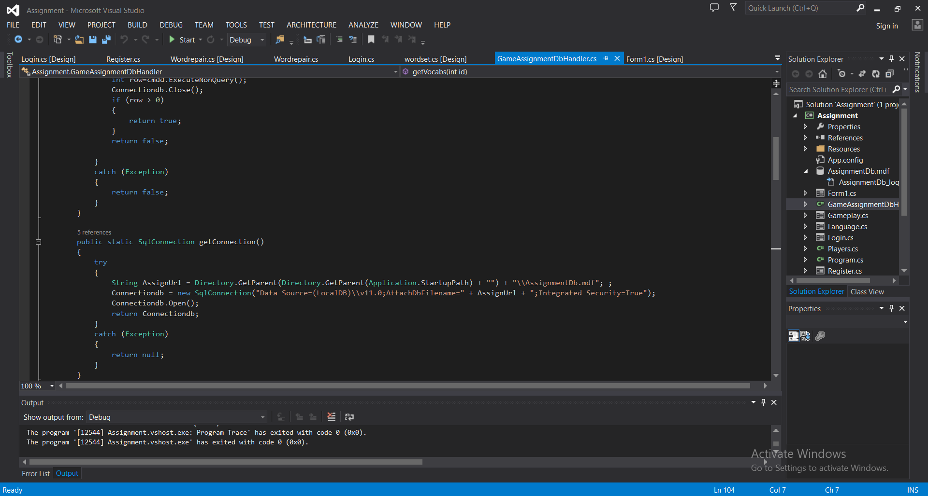

Fig 1-22

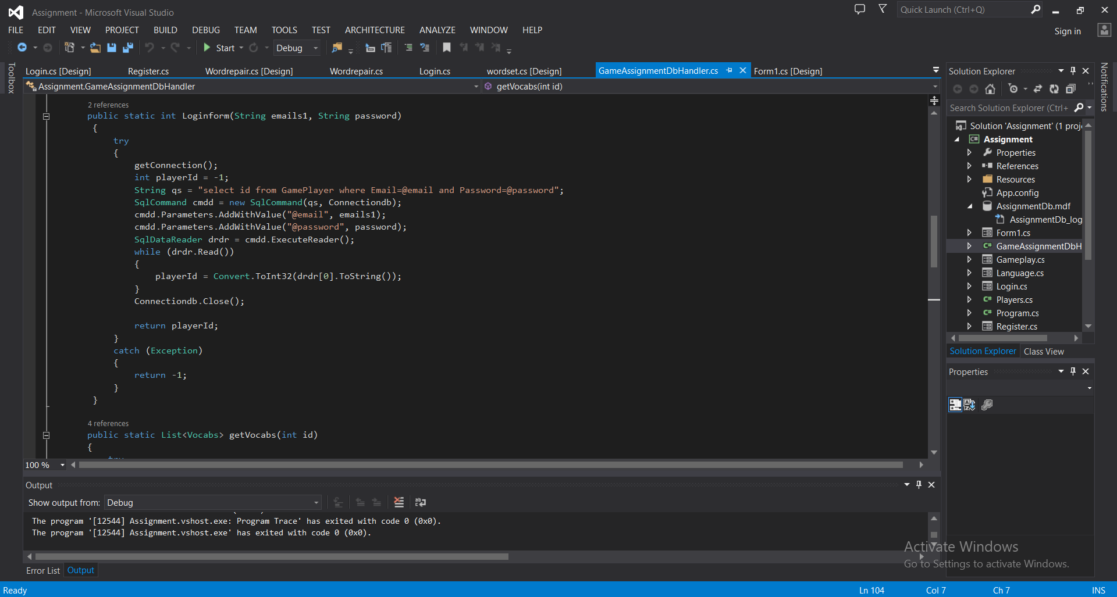

Fig 1-23

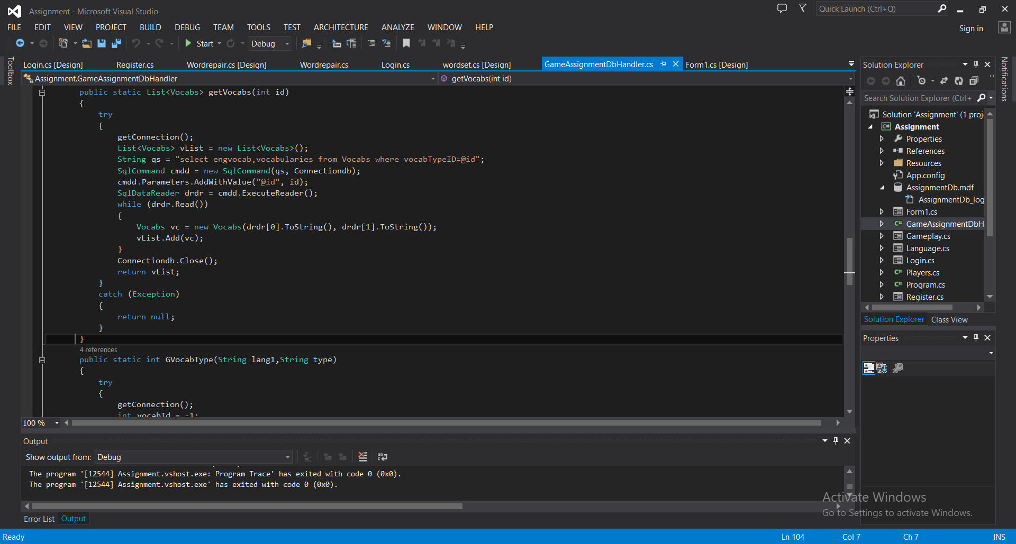

Fig 1-24

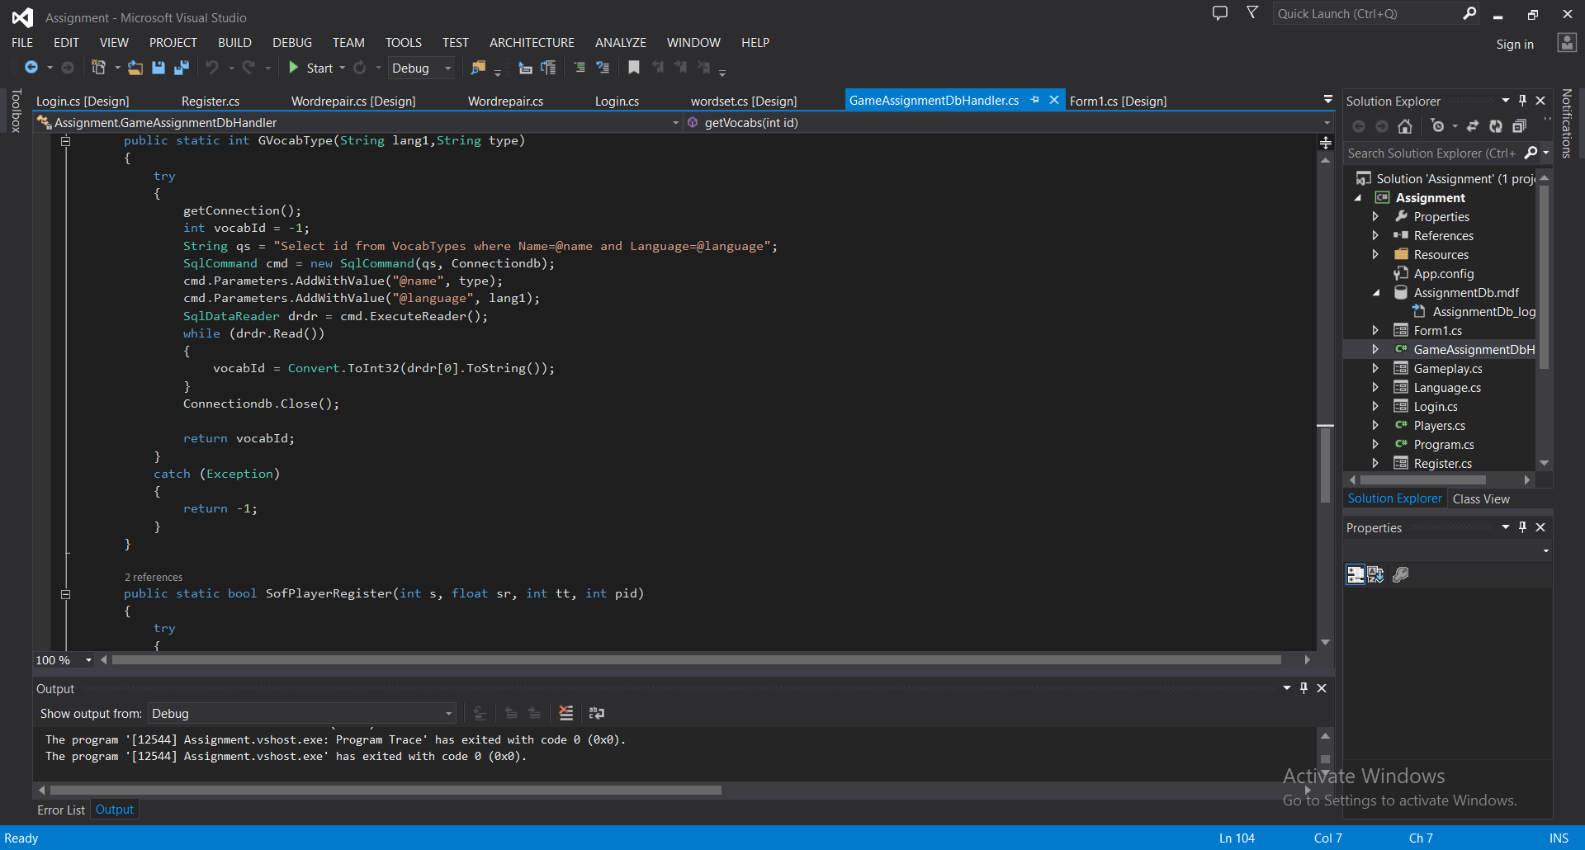

Fig 1-25

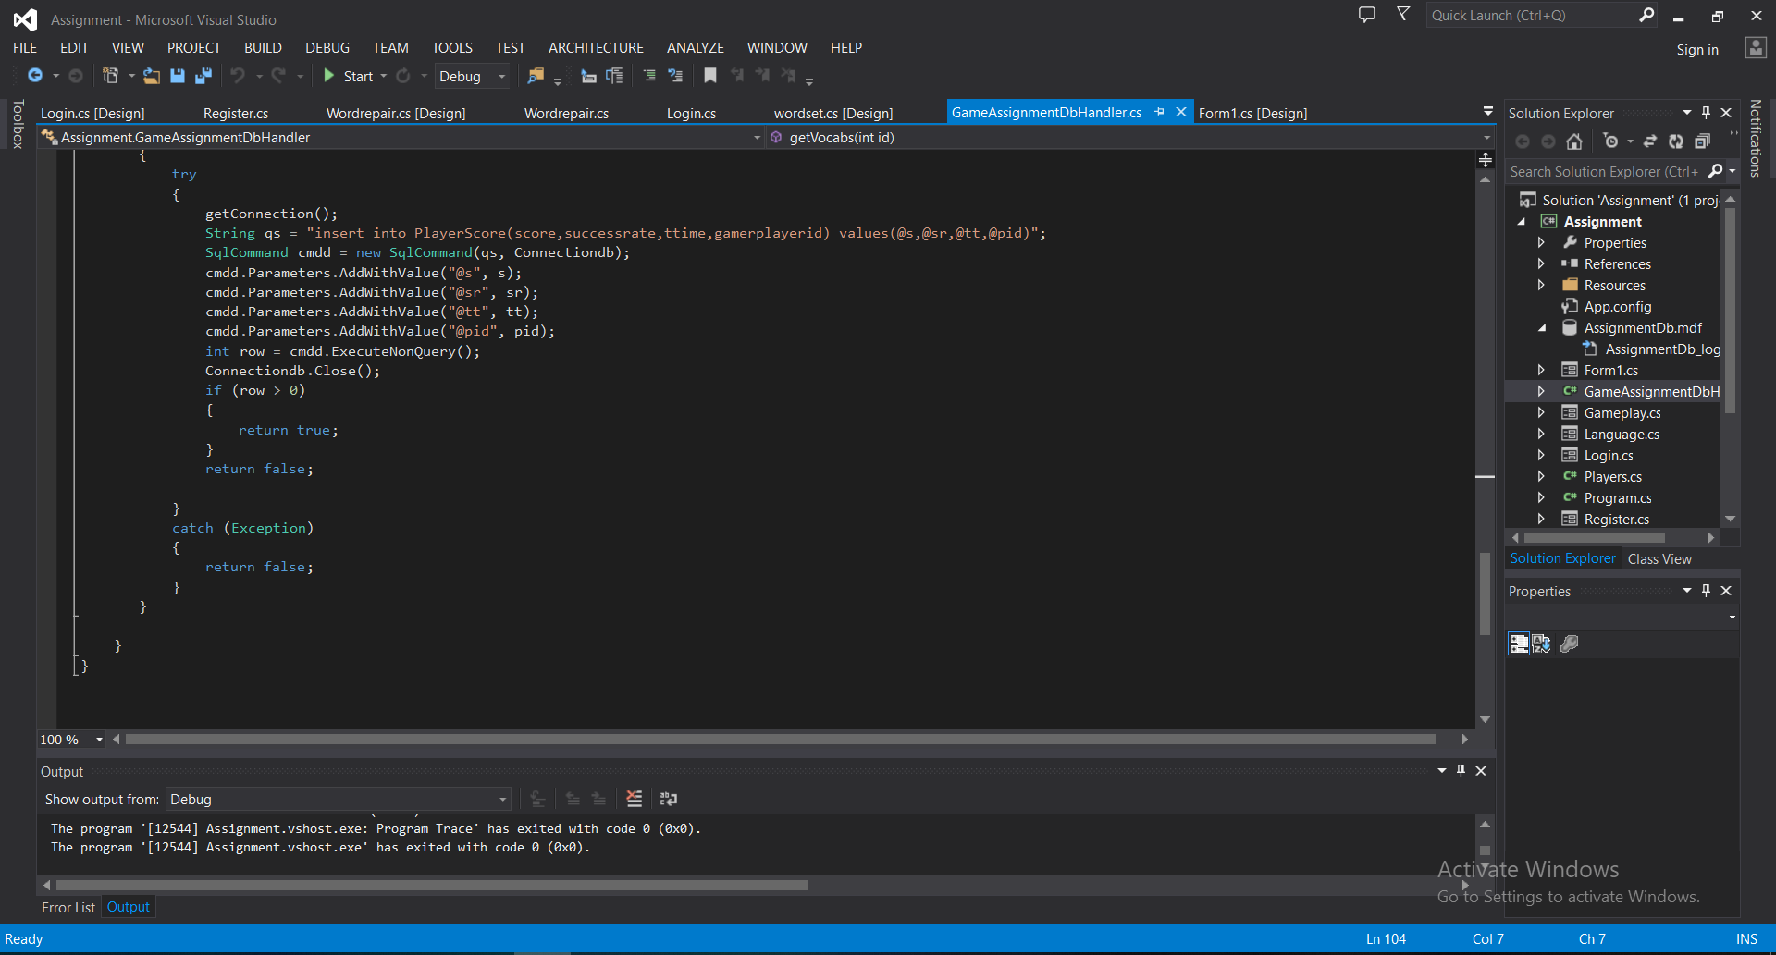

Fig 1-26

Player

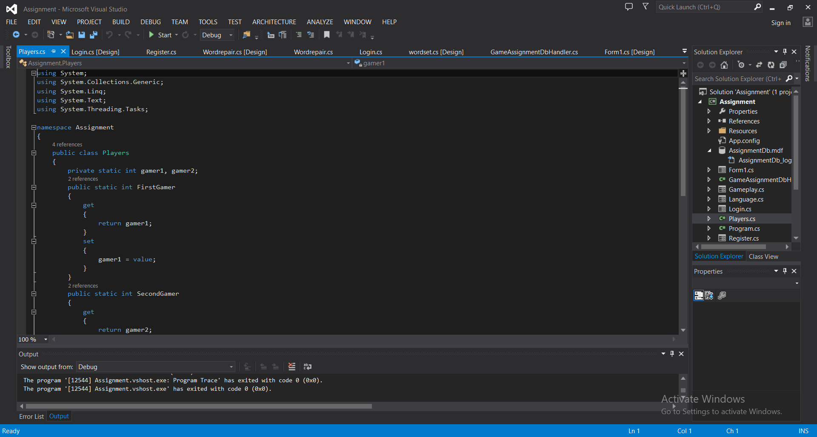

Fig 1-27

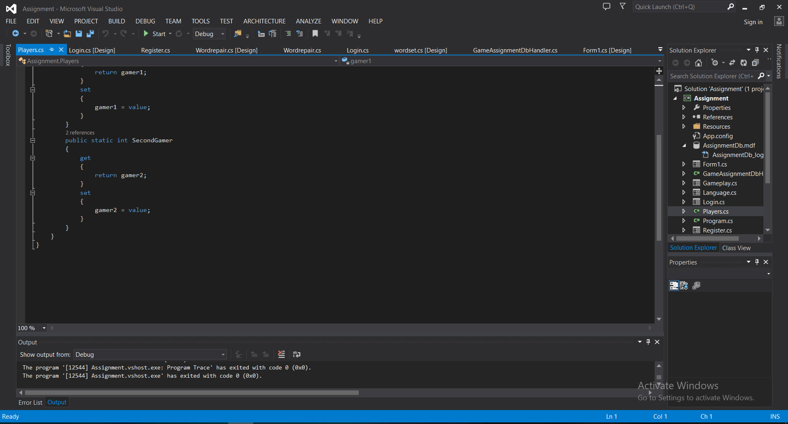

Fig 1-28

Program

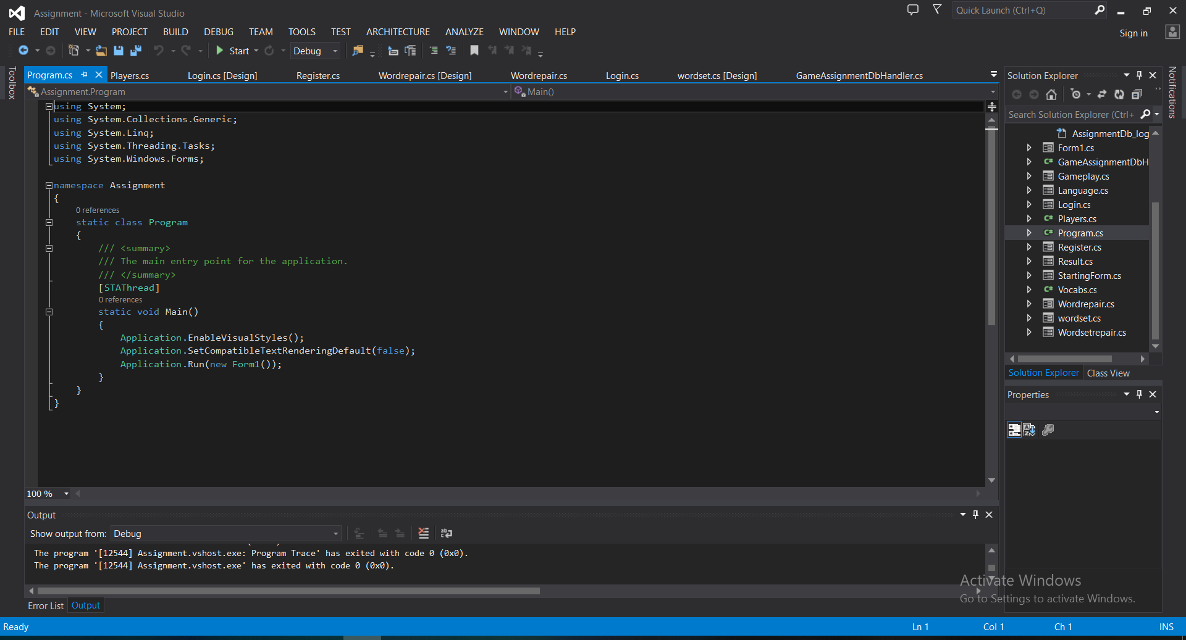

Fig 1-29

Vocabs

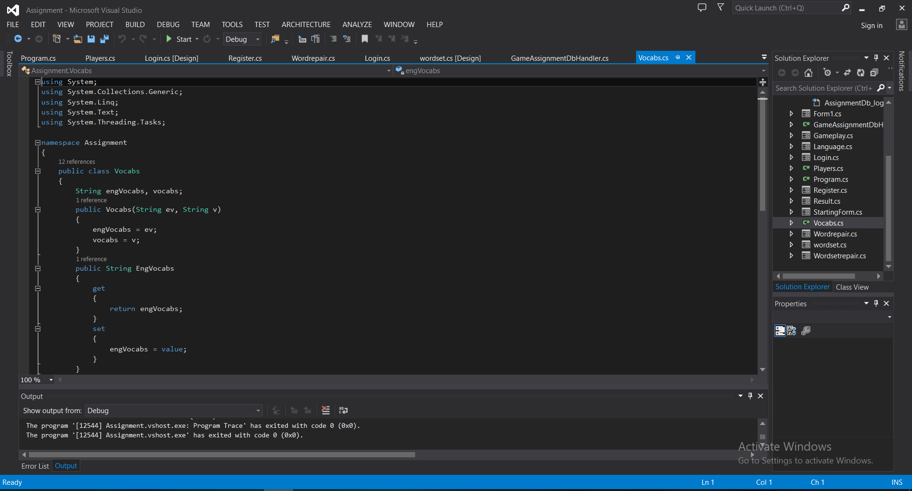

Fig 1-30

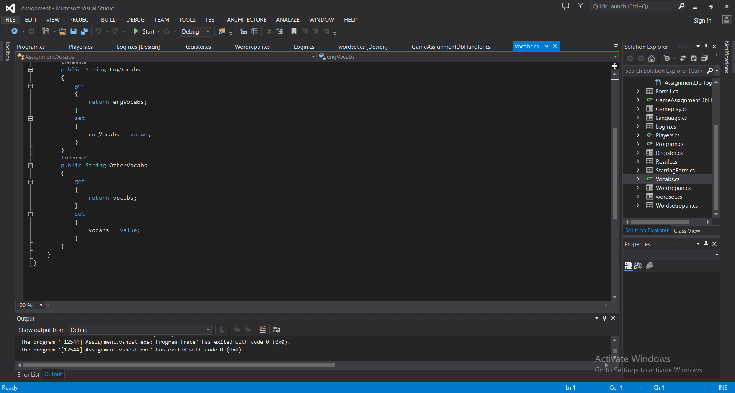

Fig 1-31

Task-2

# Task-2

|  |  |  |
| --- | --- | --- |
| Test | Expected | Actual |
| Register is failed when no data is fill | Show warning sign (***) for enter information | Show warning sign (***) for enter information |
| Registration correct | Registration complete | Registration complete |
| Password and repassword are not match when registration | Password must be match | Password must be match |
| Login will fail when no data is added | Show alert sign (***) for enter information | Show alert sign (***) for enter information |
| Login with wrong information | Wrong emails or passwords | Wrong emails or passwords |
| Login with right information | Login successful | Login successful |

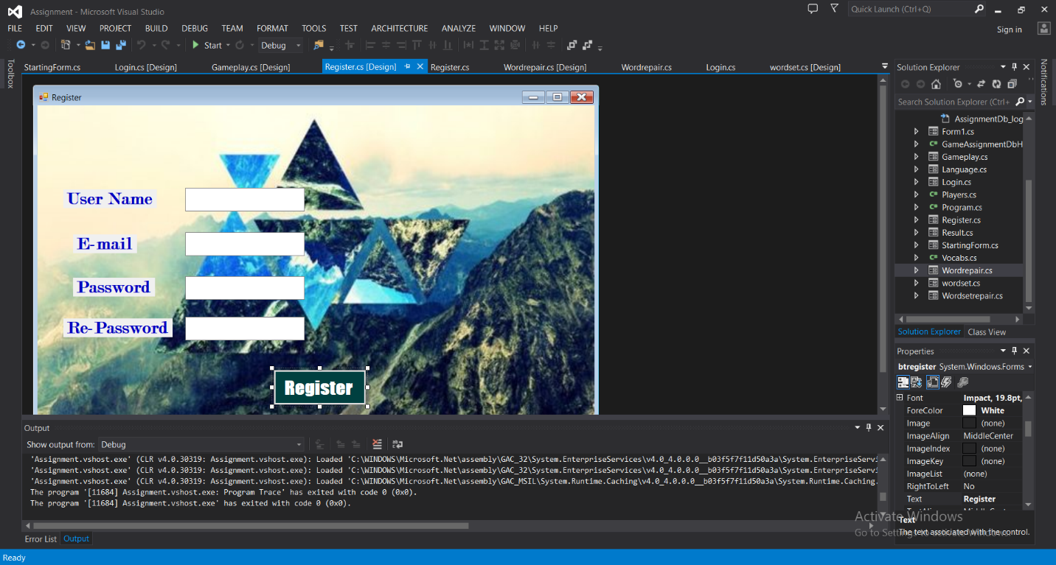

Fig 2-1



Fig 2-2

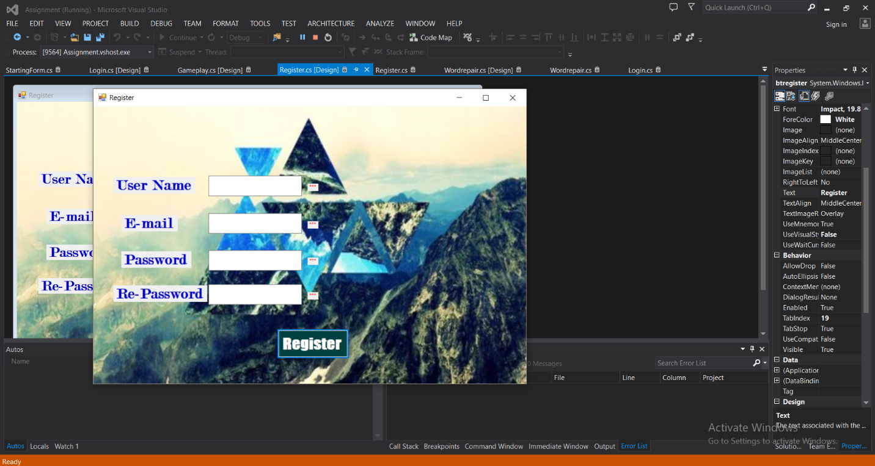

Fig 2-3

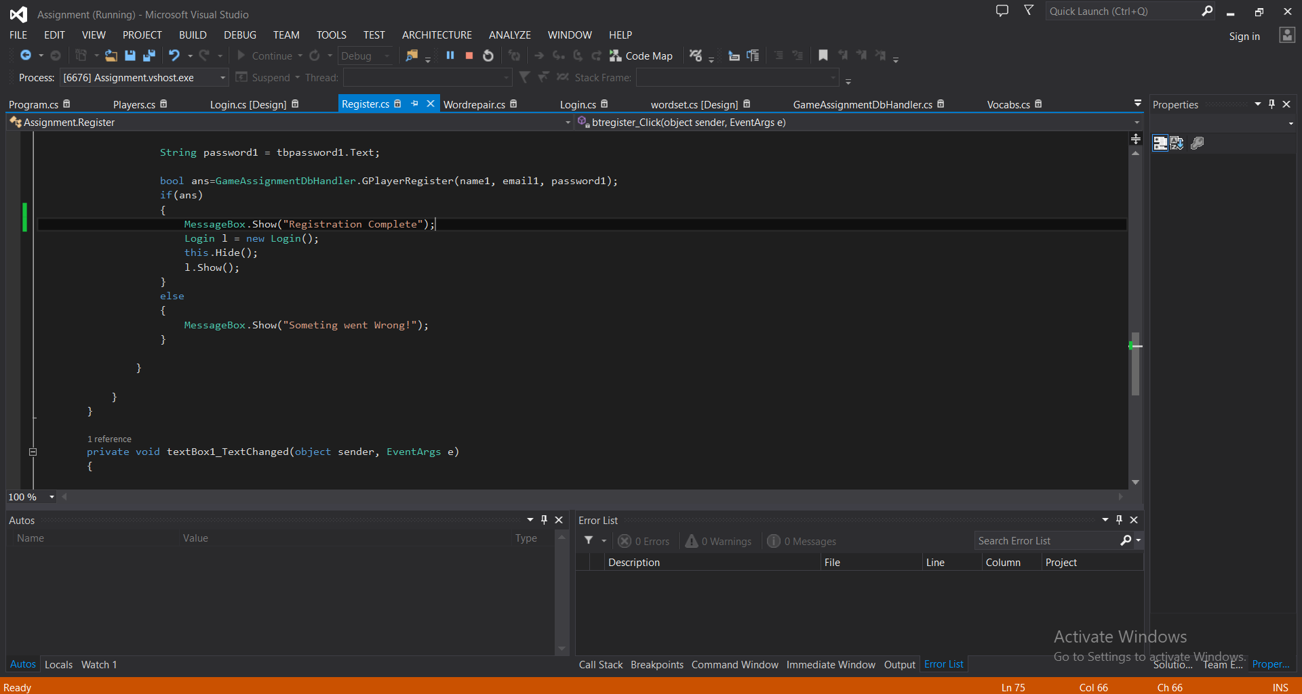

Fig 2-4

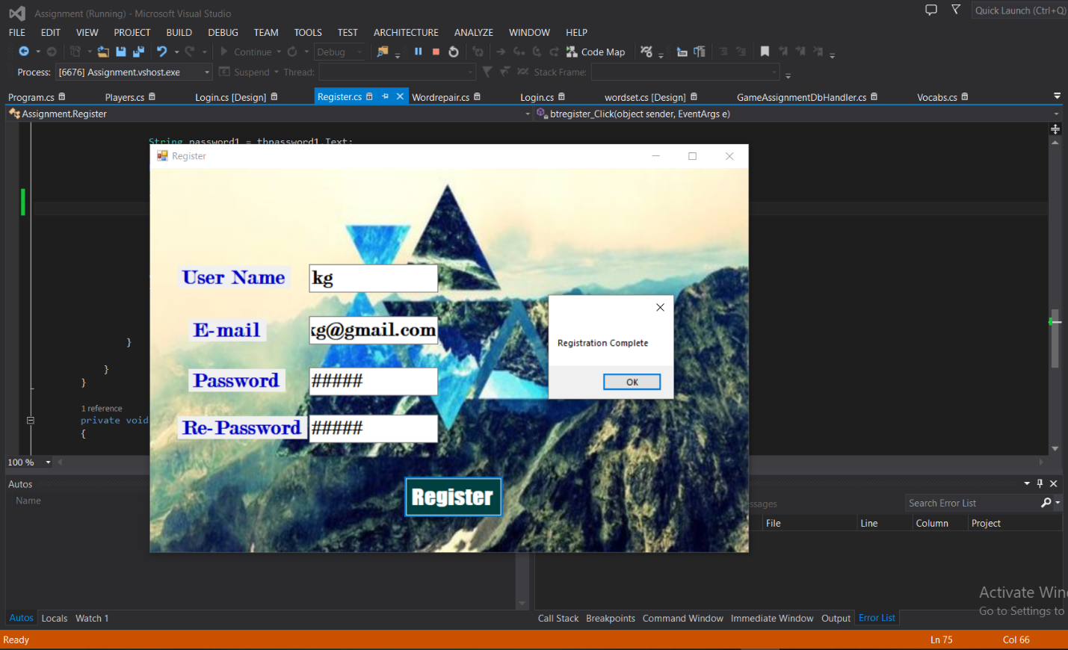

Fig 2-5

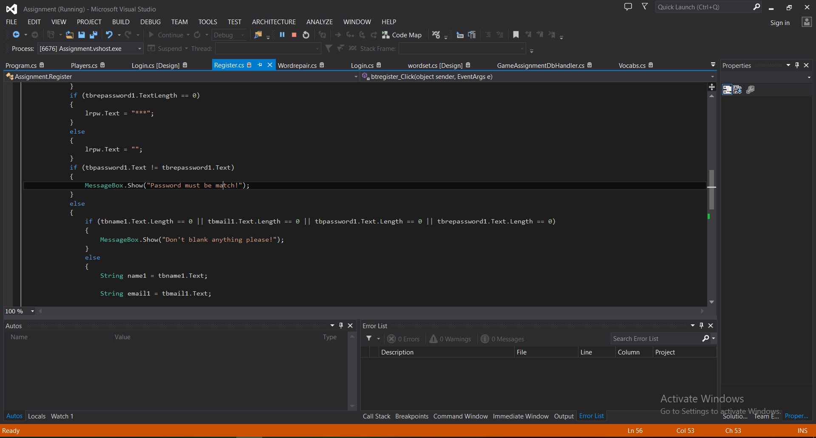

Fig 2-6

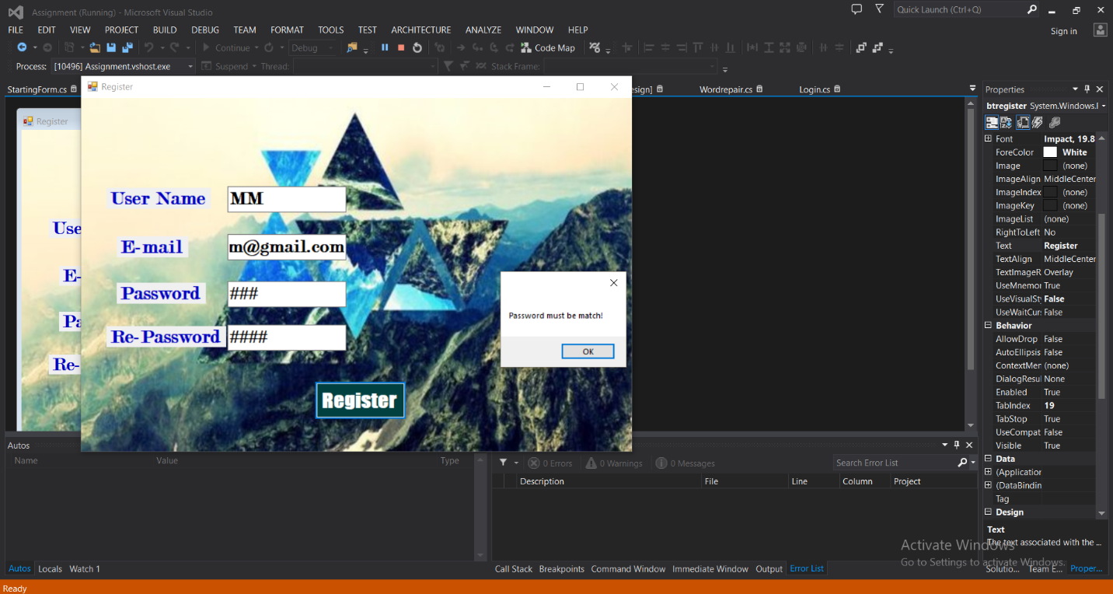

Fig 2-7

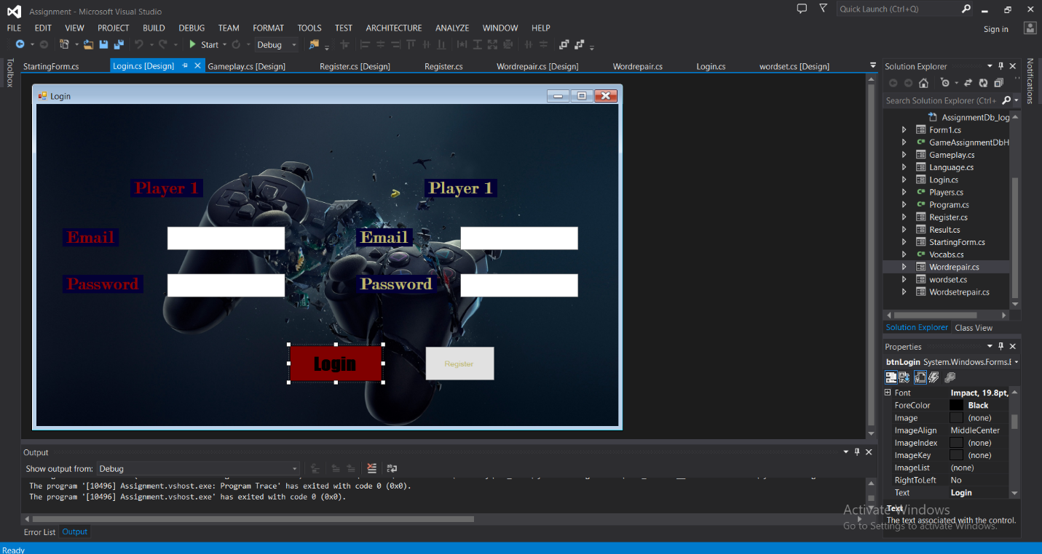

Fig 2-8

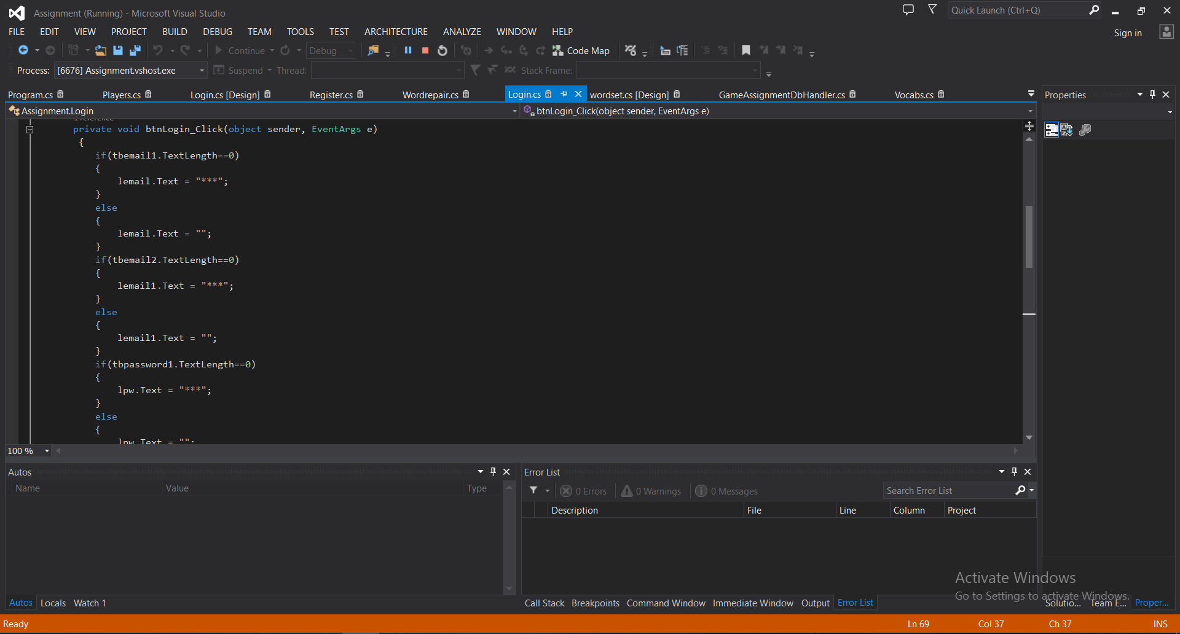

Fig 2-9

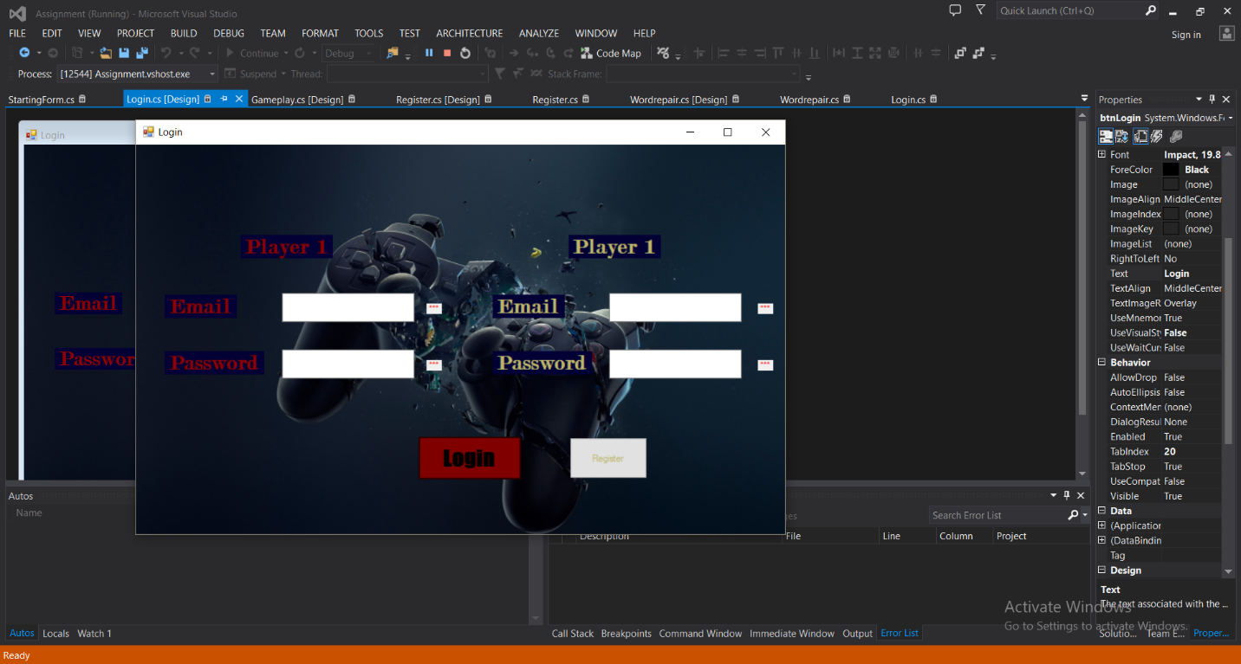

Fig 2-10

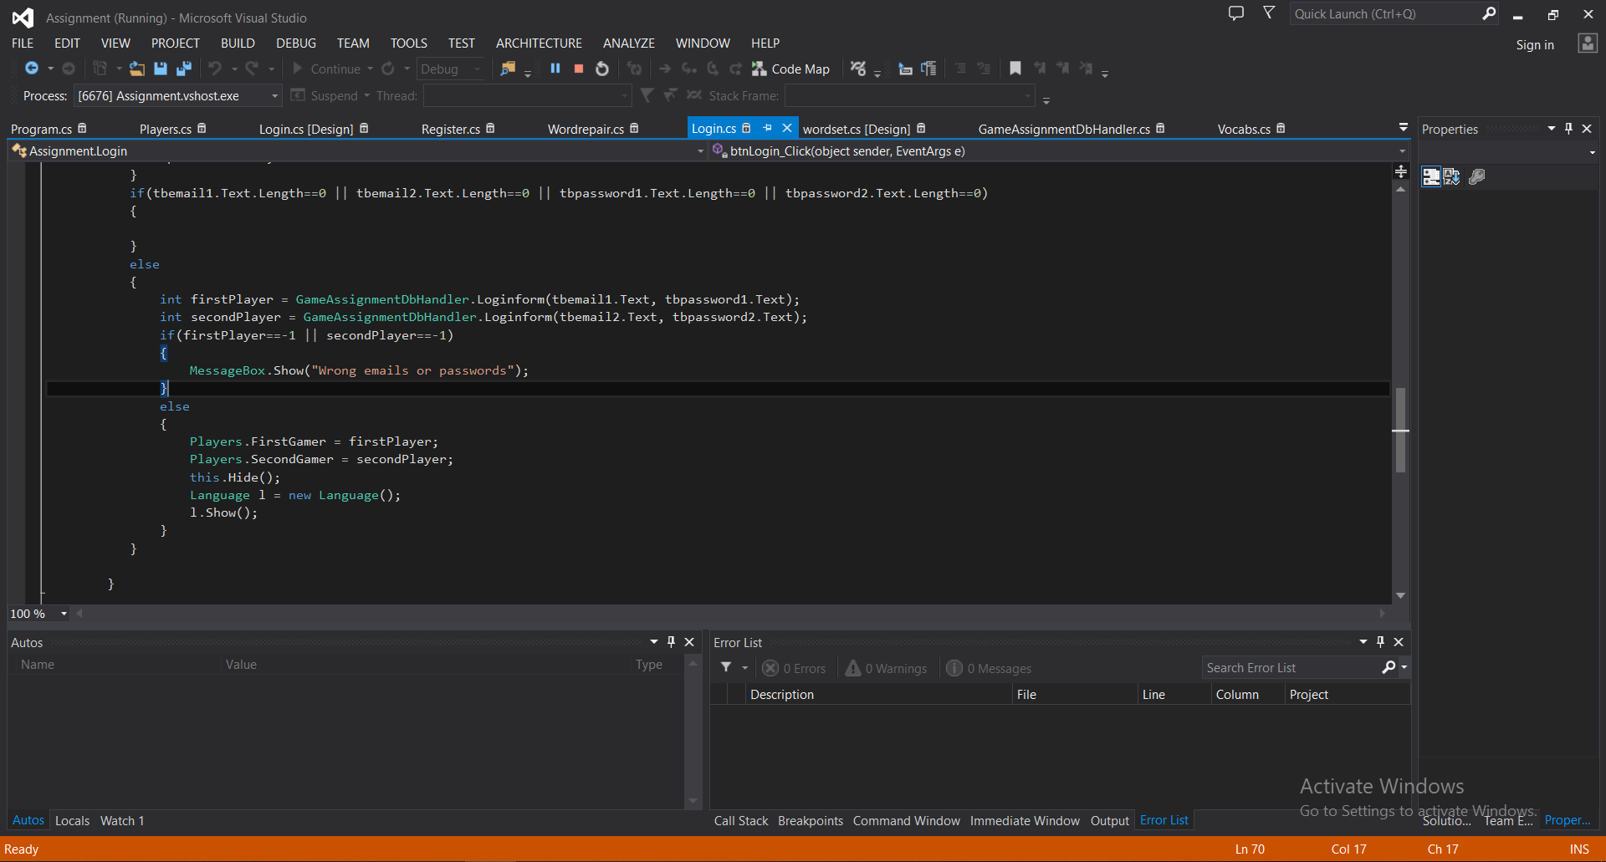

Fig 2-11

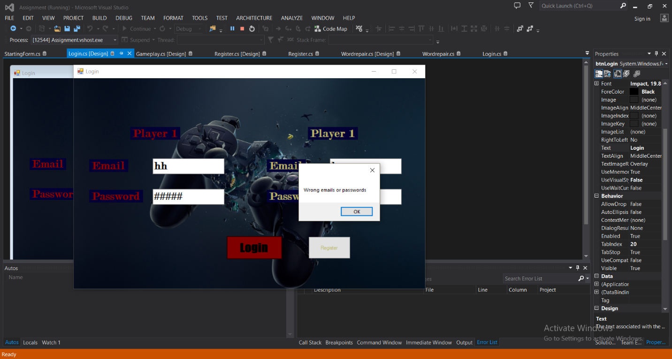

Fig 2-12

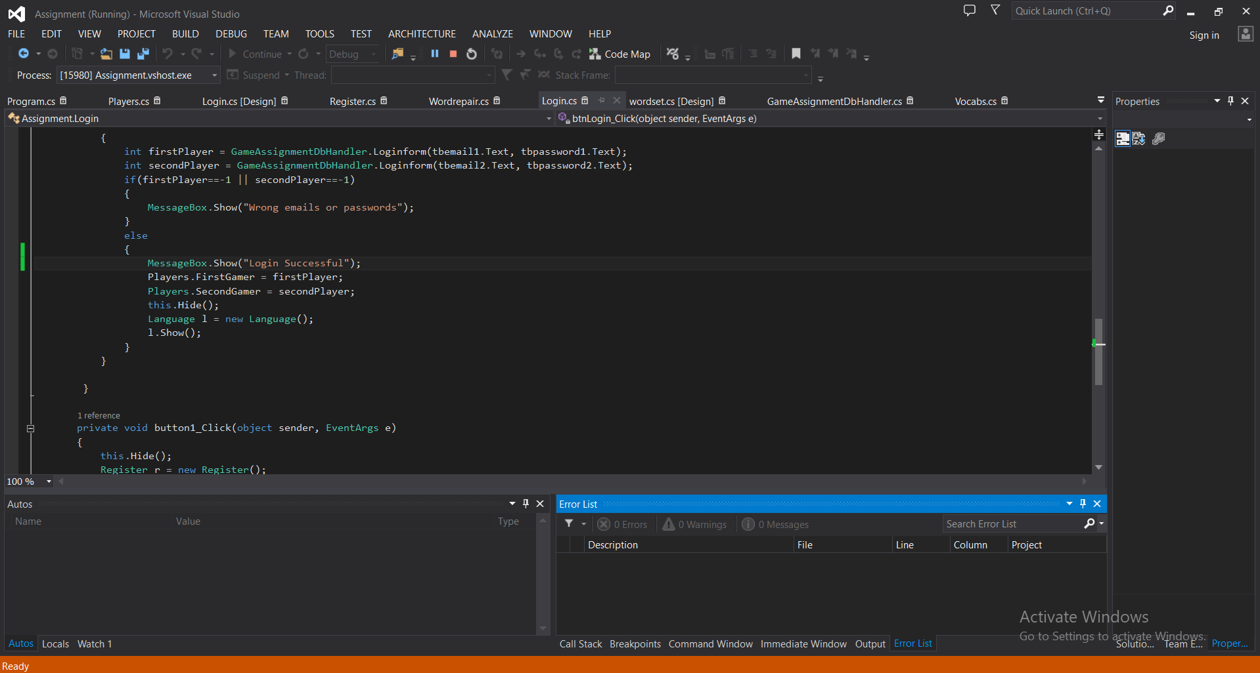

Fig 2-13

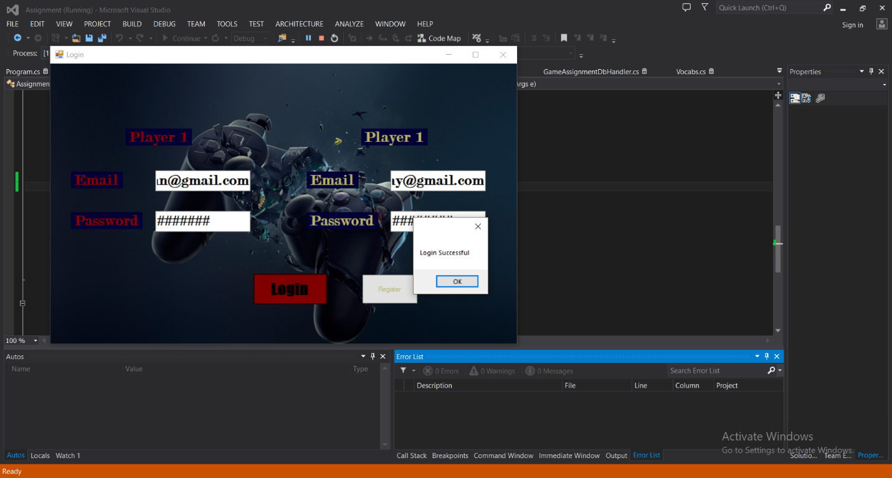

Fig 2-14

Task-3

# Task-3



Fig 3-1

Task-4

# Conclusion

Finally, I created new website for Language Trainer. Firstly, I get knowledge of C# that use for creating new website.

# References